Evaluation of HKM
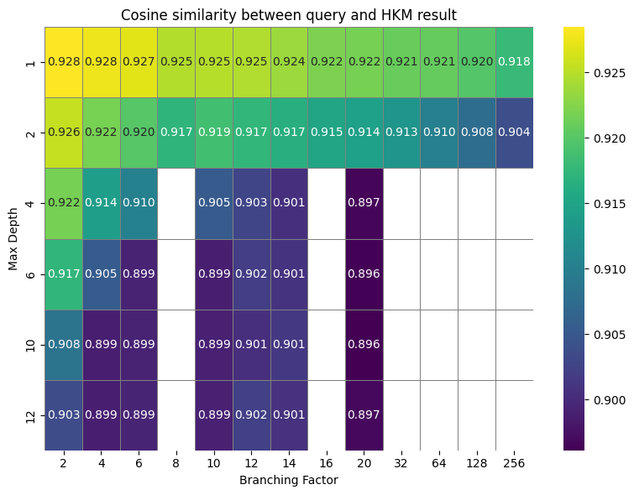
Ali Batashi – 913444
k-NN clustering algorithm is highly dependent on the number of clusters k and the initialization. Every point must be assigned a cluster so outliers are a big issue especially given datasets with millions of entries.
HKM is less sensitive to its construction parameters and benefits from logarithmic time complexity. The speedup with respect to a full linear search is:
O(k ^{-M_max})
My implement is inspired by the provided pseudo code while using normalized data so distance between vectors is proportional to inner product.

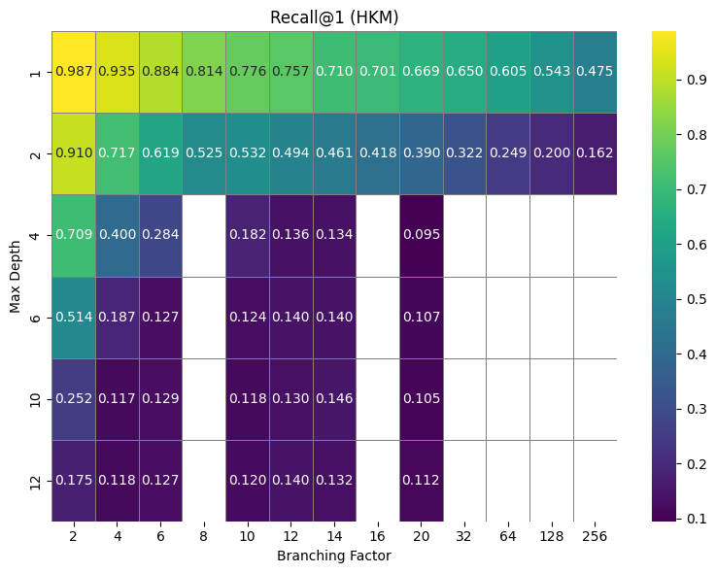
Influence of the Construction Parameters
Figure 1
As evident in figure 1, the best recall comes from a narrow (low k) and shallow ( low M_max) tree. Such a tree is very similar to performing a linear search so if your goal is to speed up the linear search process, such a configuration is ideal. Setting both k and M_max to 1 means that each query is compared to every datapoint. An interesting observation is that setting k to 2 and M_max to 1 results in the same recall as a liner search but each query is twice as fast, as we anticipated.
Recall isn’t the only decisive metric. Let’s consider cosine similarity; even when the HKM is wrong, the cosine similarity between the nearest neighbor and the query is greater than 0.89 which is still acceptable depending on the application.
Figure 2
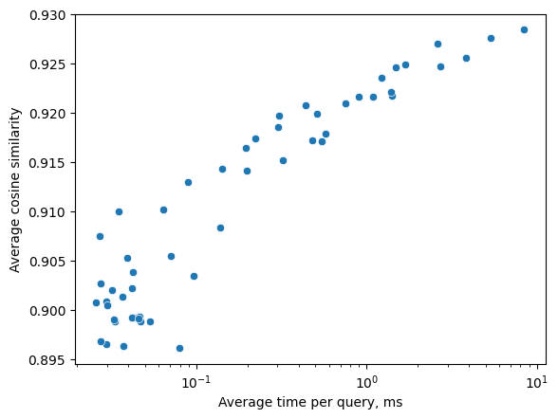
As the tree becomes deeper and/or wider, you will have to make more random decisions with k-means and even if one of them is incorrect, then the result will also be incorrect (yet very close to the query). The color in the heatmap perfectly depicts this. There is also no backtracking so once wrong split is enough to get the wrong result. On the other hand, such a wide and/or shallow tree means making less comparisons so the query times will be much better.
Figure 3
I have set

